Part 1 Code

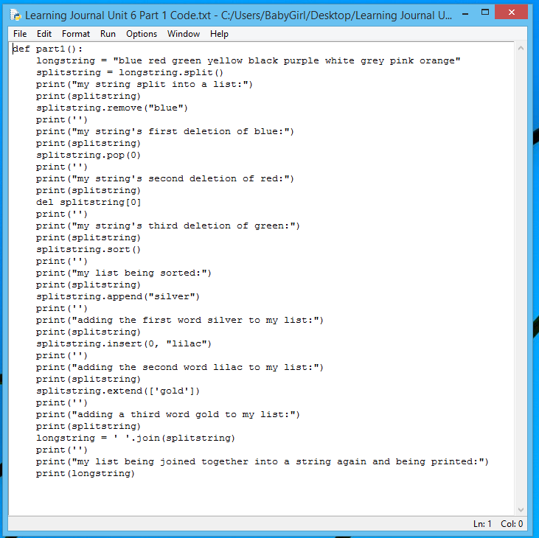

Part 1 Output

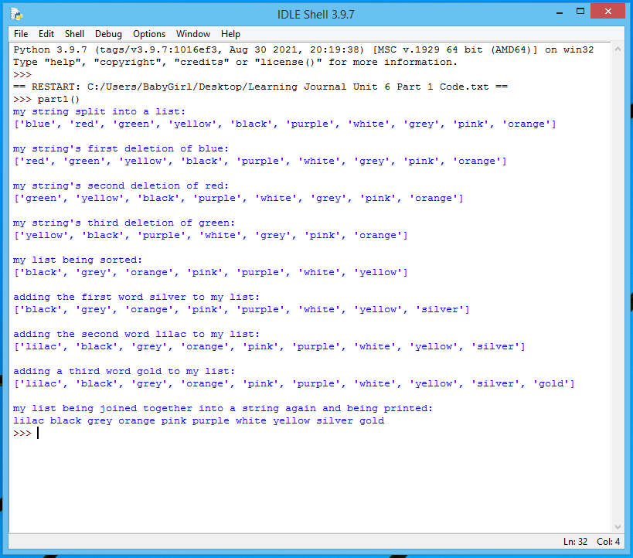

Part 2 Code

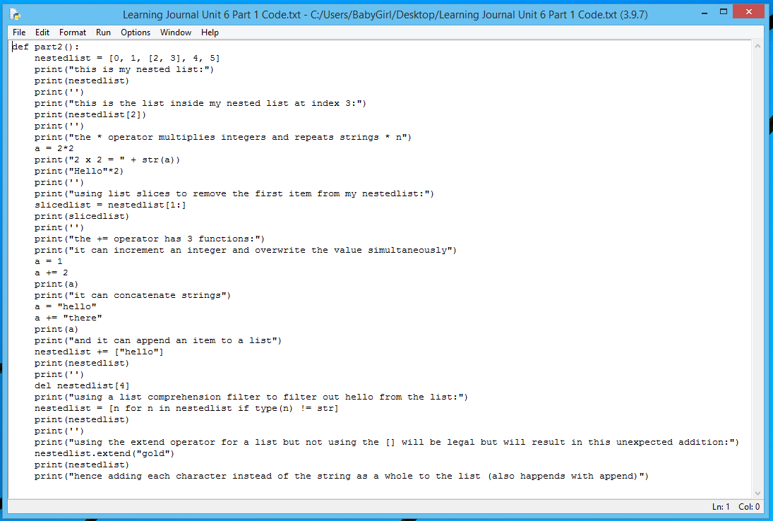

Part 2 Output

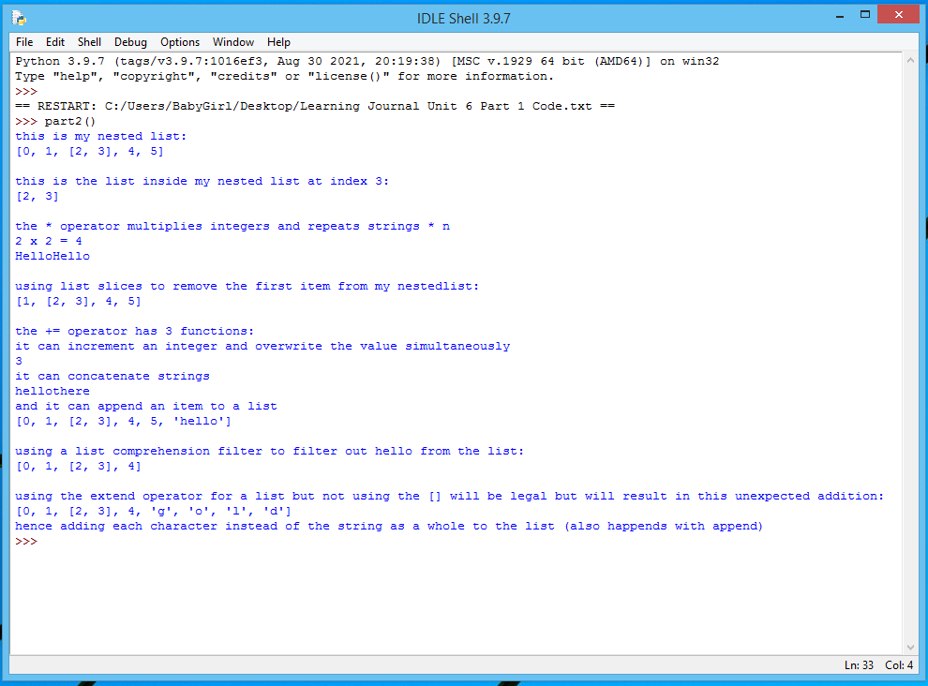

Part 3

Describe your experience so far with peer assessment of Programming Assignments.

My experience with the peer assessments has been positive to this point.

How do you feel about the aspect assessments and feedback you have received from your peers?

I am okay with the assessments I have received so far. I worry more about the assessments my instructor gives me when it relates to grades than those of my peers. The feedback from my peers I value more than the grades as it promotes self-reflection and I just try to learn from it, not to worry about what my grade will be.

How do you think your peers feel about the aspect assessments and feedback you provided them?

I hope that I have graded and assessed correctly. I have done all I can to follow the grading rubric correctly and to provide useful feedback wherever possible.